A76-AM,S-Peru-Moche-Mask-Nose piece-Copper-Owl Head Effigies

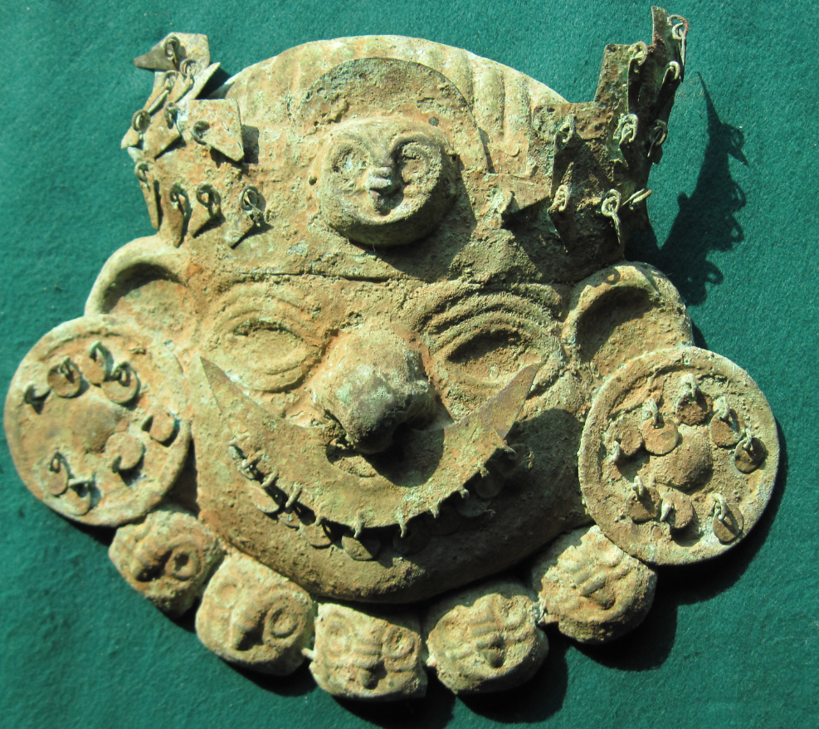 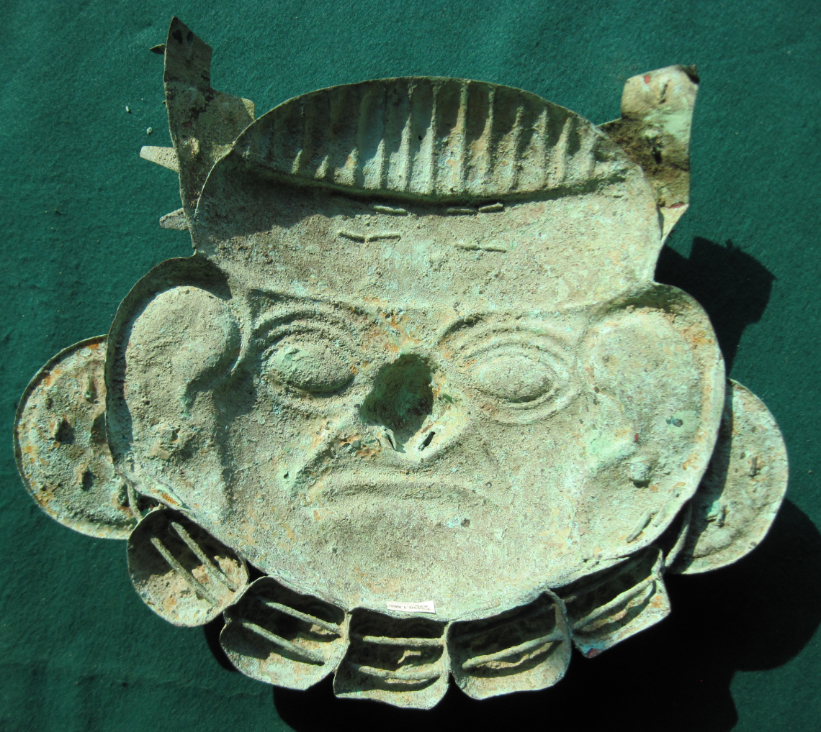

Figs. 1-2. Peru-Moche-Mask-Nosepiece-Copper-Owl Head Effigies.

**Case no.: 7**

**Accession Number: A74**

**Formal Label:**

**Display Description:**

A large copper mask of a male dignitary with a lineal-woven textile cap. He has almond-shaped eyes, a broad nose and fully shaped ears. A wide crown with stepped pyramidal structures on either side in which are eleven “V”-shaped hanging, copper spangles. At the center of the crown is an owl maskette within a lunette. Below the face are an additional five owl maskettes. The figure is wearing large, round ear disks outlined by a ridge in which are eight circular copper sequins surrounding a central boss. A large crescent-shaped nose ornament with twelve copper spangles (three are missing) is attached to the nose. This is an unusual mask in that both sides offer different vantage points of viewing the dignitary: the reverse show him in his regalia and the obverse shows him in a more natural pose without his regalia.

**LC Classification: F3430.1.**

**Date or Time Horizon:** 100 BCE-400 CE

**Geographical Area:** N coastal Peru

**Map, GPS coordinates:**

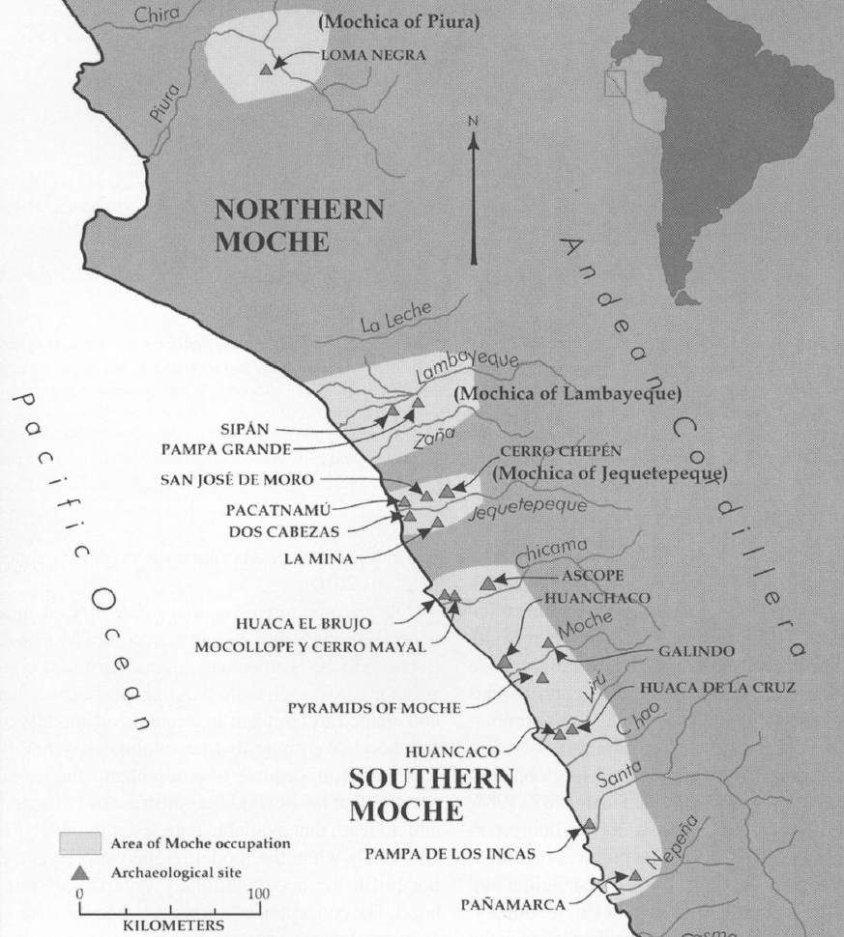

Fig. 3. Map of Moche regions as currently conceived and significant Moche sites. Map courtesy Moro Archaeological program.

**Cultural Affiliation:** Moche (Mochica)

**Medium:** Copper sheet with heavy encrusted verdigris patina. Ancient, cuprite and metallic sediment deposits yields a beautiful olive-green to brown patina on reverse and olive-green on obverse.

**Dimensions:** H226.73 mm, 8.93 in;

**Weight: 357 gm, 12.50 oz.**

**Condition: Original.** Ancient, cuprite and metallic sediment deposits yields a beautiful olive-green to brown patina on reverse and olive-green on obverse.

**Provenance:** Ex. Arte Primitivo, Ex. Howard Nowes Gallery “Art for Eternity”.

AP 15x103 http://muzeiongallery.com/

**Discussion:** Owl maskettes were worn as pendants as the following example illustrates:

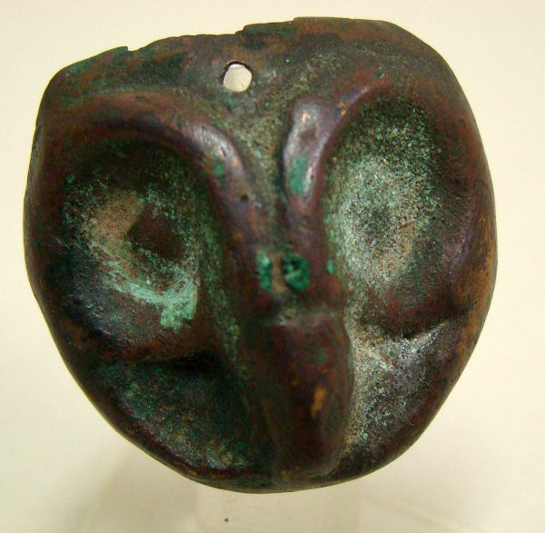

Moche, 500 – 800 AD/CE. A small and fine copper mask in the form of the head of an "owl". Mask is circular shaped with typically large eyes and long and narrow pointed beak. Hole appears at the center top portion of mask. Perhaps was worn as a pendant on a necklace. Nice patina with slight losses at extreme top portion. D: 1 3/8". Sits nicely on custom Lucite stand. Joel L. Malter Collection. From <https://p1.liveauctioneers.com/95/13904/428286>

_1_l.jpg?version=1191273765

**References:**

Berezkin, Yuri. 1980. “An Identification of Anthropomorphic Mythological Personages in Moche Representations,” *Ñawpa Pacha,* 18:1-26.

Quilter, Jeffrey. 1990. “The Moche Revolt of the Objects,” *Latin American Antiquity,* 1:42-65.

Quilter, Jeffrey.1997. “The Narrative Approach to Moche Iconography,” *Latin American Antiquity,* 8:113-133.

Quilter, Jeffrey. 2002. “Moche Politics, Religion, and Warfare,” *Journal of World Prehistory,* 16:145-195.

Quilter, Jeffrey. 2008. “Art and Moche Martial Arts.” In *The Art and Archaeology of the Moche*, edited by Bourget, Steve and Kimberly L. Jones, pp. 215-228. Austin: University of Texas.

Quilter, Jeffrey. 2010. *Moche: Media and Messages*. Cambridge: Peabody Museum Press, Harvard University.

Quilter, Jeffrey, and Luis Jaime Castillo Butters (editors) 2010. *New Perspectives on Moche Political Organization*. Cambridge: Dumbarton Oaks.

Quilter, Jeffrey, and Michele L. Koons, M. 2012. “The fall the Moche: a critique of claims for South America’s first state,” *Latin American Antiquity*, 23(2), 127-143.